LangChain Models | Indepth Tutorial with Code Demo
https://www.youtube.com/watch?v=HdcLE8JuMrA&list=PLKnIA16_RmvaTbihpo4MtzVm4XOQa0ER0&index=5
https://github.com/campusx-official/langchain-models
00:00 – Intro
00:55 – Recap
02:18 - What are Models?
06:56 - Plan of Action
09:01 - Language Models
16:20 – Setup
20:37 - Code Demo
53:26 - Open Source Models
01:29:52 - Embedding Models
1. Intro – What this video is about
Key intent of the video:
- Understand what models are in LangChain
- Learn different types of models
- Use them practically by writing code
- Build small but meaningful applications
Core idea: You learn GenAI best when you actually build things and see them working.

2. Recap – Context from previous videos
Before diving into models, the instructor revisits what has already been covered:
- Video 1
  - What LangChain is
  - Why LangChain is needed
  - Types of applications you can build with it
  - Alternatives to LangChain
- Video 2
  - Core LangChain components:
    - Models
    - Prompts
    - Chains
    - Agents
    - Others
  - Why each component exists
  - Where each component is used in real applications
This video is a deep dive into the first and most fundamental component: Models.

3. What are Models in LangChain?
The Models component in LangChain is a crucial abstraction layer.
Simple definition
LangChain’s model component provides a common interface to interact with different AI models.
Why this is needed
Different AI providers (OpenAI, Anthropic, Google, Hugging Face, etc.) expose their models in different ways:
- Different APIs
- Different request formats
- Different response structures
LangChain hides this complexity and lets you work with all of them in a consistent way.
Core responsibility of the Models component
- Connect your application to AI models
- Allow switching models without rewriting your entire codebase

4. Types of Models in LangChain
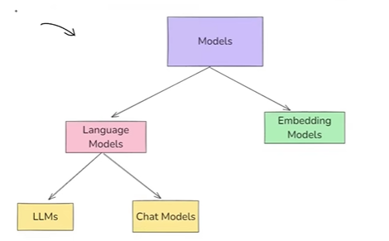
LangChain primarily works with two categories of models:
4.1 Language Models
Language Models:
- Take text as input
- Return text as output
Example:
- Input: “What is the capital of India?”
- Output: “New Delhi”
These models are used for:
- Chatbots
- Text generation
- Summarization
- Question answering
- Code generation
4.2 Embedding Models
Embedding Models:
- Take text as input
- Return a vector (list of numbers) as output
These numbers represent the meaning (semantic context) of the text.
Example:
- Input: “What is the capital of India?”
- Output: [0.012, -0.45, 1.23, ...] (a vector)
These vectors are used for:
- Semantic search – It is helpful in RAG Based Applications (PDF loader example)
- Similarity comparison
- Recommendation systems
- Retrieval-Augmented Generation (RAG)

5. How these models are used in real applications
Language Models → Conversational & Generative Tasks
Used when:
- You want human-like responses
- You want natural language output
Typical applications:
- Chatbots
- AI tutors
- Coding assistants
- Customer support bots
Industry perspective (important here)
Most GenAI products today (ChatGPT-like apps, copilots, assistants) are language-model-driven systems.

Embedding Models → Search & Retrieval Tasks
Used when:
- You want to compare meaning, not keywords
- You want to search documents intelligently
Typical applications:
- Document search
- “Chat with your PDFs”
- Resume matching
- Product recommendation
Industry perspective (important here)
Almost every enterprise GenAI system uses embeddings internally:
- Knowledge bases
- Internal documentation bots
- Customer query matching
- Legal and medical document retrieval

6. Why Embeddings are critical for RAG systems
The instructor indirectly introduces RAG (Retrieval-Augmented Generation).
In RAG:
- Documents are converted into embeddings
- User query is also converted into an embedding
- Similarity search is performed
- Relevant documents are sent to a language model
- Language model generates an informed answer
Even if RAG is not fully covered yet, this video establishes:
Embeddings are the backbone of RAG-based applications

8. Plan of Action for this video
The instructor clearly defines the learning path:
- Work with Language Models
  - Closed-source (paid) models
    - OpenAI (GPT)
    - Anthropic (Claude)
    - Google models
  - Open-source models
    - Hugging Face
- Work with Embedding Models
  - Closed-source embeddings (OpenAI)
  - Open-source embeddings (Hugging Face)
- Build a Document Similarity application
  - Compare two documents
  - Generate a similarity score
This plan mirrors real industry workflows.

9. Language Models – deeper understanding
Language models are further divided into two types:
9.1 LLMs (Large Language Models – older style)
Characteristics:
- Input: plain text
- Output: plain text
- General-purpose NLP models
Used for:
- Text generation
- Summarization
- Translation
- Code generation
Important note:
- LLM-style APIs are slowly being deprecated in LangChain
- Not recommended for new projects

9.2 Chat Models (modern standard)
Characteristics:
- Designed for conversation
- Accept a sequence of messages
- Understand conversation history
- Support roles (system, user, assistant)
Capabilities:
- Multi-turn conversations
- Context awareness
- Role-based behavior
Industry perspective (very important)
Modern GenAI industry has almost completely shifted to chat models:
- Chatbots
- AI agents
- Coding assistants
- Virtual assistants
LangChain itself encourages:
Use chat models for new applications

10. LLMs vs Chat Models – practical comparison
How LLMs and Chat Models Are Trained
LLMs (Large Language Models)
LLMs are trained on a huge amount of text data, such as:
- Books
- Articles
- Websites
- Code repositories
Their main goal is to learn language patterns, grammar, facts, and relationships between words.

Chat Models
Chat models are first trained on the same large text data as LLMs.
After that, they are fine-tuned on conversational data, such as:
- Chat conversations (e.g., WhatsApp-style chats)
- Reddit discussions
- Question–answer datasets
- Human feedback
This fine-tuning helps them:
- Respond naturally in conversations
- Follow instructions better
- Maintain context in dialogue

Role Assignment in Chat Models
One special feature of chat models is that we can assign roles to them.
Example:
We can instruct the chat model like:
“You are an experienced doctor.”
After this, the chat model will respond in a way that matches the knowledge and tone of a doctor.
Aspect | LLMs | Chat Models
Purpose | General NLP | Conversational AI
Input | Single text string | Message sequence
Memory | No | Yes
Role awareness | No | Yes
Industry usage | Declining | Dominant

11. When to use which model
Use LLMs (only if needed):
- Simple text generation
- Legacy systems
- Quick experiments
Use Chat Models (recommended):
- Chatbots
- Virtual assistants
- AI tutors
- Customer support bots
- Coding assistants
Most real-world GenAI products fall into the second category.

12. Project ideas (only where it makes sense)
Project 1: Conversational AI Chatbot
- Use a chat model
- Maintain conversation history
- Assign system roles (e.g., “You are a career advisor”)
Industry relevance: Very high

Project 2: Document Similarity Checker
- Use embedding models
- Compare multiple documents
- Output similarity scores
Industry relevance: Resume screening, plagiarism detection, legal analysis

Project 3: “Chat with Documents” (RAG foundation)
- Convert documents to embeddings
- Perform semantic search
- Feed results to a chat model
Industry relevance: Enterprise knowledge assistants

13. Key takeaway from this part
- Models are the foundation of LangChain
- You must clearly understand:
  - Language vs Embedding models
  - LLMs vs Chat models
- Industry is heavily biased toward chat models
- Embeddings silently power most “intelligent” features

14. Environment Setup for GenAI Development
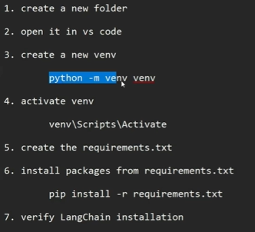
This section focuses on creating a clean and reproducible development setup, which is critical before writing any GenAI code.
Key steps explained
- Create a dedicated project folder (e.g., langchain_models)
- Open the folder in VS Code
- Use a Python virtual environment to isolate dependencies
- Install all required libraries using a single requirements.txt file
Why this matters in industry
- Companies never install libraries globally
- Each project has:
  - Its own dependencies
  - Its own versions
  - Its own environment
This avoids:
- Dependency conflicts
- “It works on my machine” problems
This setup mirrors real-world production workflows.

15. Importance of Using requirements.txt
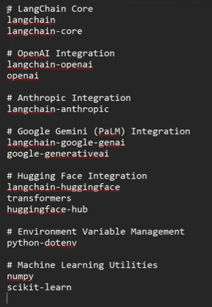
Instead of installing libraries one by one, all dependencies are listed in a single file.
Benefits
- Easy onboarding for new developers
- Consistent environments across:
  - Developers
  - Servers
  - CI/CD pipelines
Industry perspective
In real teams:
- requirements.txt or pyproject.toml is mandatory
- Cloud deployments often fail if this is missing or incorrect
This is not optional knowledge — it’s industry hygiene.

16. Verifying LangChain Installation
A small test file is created to:test.py
- Import LangChain
- Print its version
Why this check is important
- Confirms successful installation
- Ensures compatibility with examples shown later
Industry practice
Before integrating any major library:
- Teams verify versions
- Lock versions to avoid breaking changes
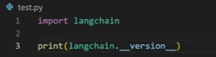
To run the Python file -> python test.py

17. Logical Folder Structure for GenAI Projects
Three folders are created:
- llms
- chat_models
- embedding_models
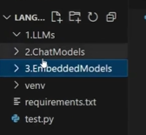
Why this structure is smart
It reflects how GenAI systems are architected, not just tutorial convenience.
Industry mapping
Folder | Real-world usage
LLMs | Legacy / learning
Chat Models | Core applications
Embeddings | Search, RAG, recommendation
This structure prepares you for scalable GenAI systems.

18. Why Start with LLMs (Even Though They Are Legacy)
The instructor deliberately starts with LLMs using OpenAI.
Reason
- LLMs are simpler:
  - String in → string out
- Easier to understand:
  - Prompt
  - Response
  - Invocation flow
Important clarification
This is for learning, not best practice.
Industry reality
- New systems rarely use raw LLM APIs
- Chat-based APIs dominate production

19. OpenAI API as an Industry Standard (Still)
The need for OpenAI API keys and credits is discussed.
Key points
- OpenAI no longer provides free credits
- Minimum paid balance is required
- Small investment (≈ $5) is sufficient for learning
Industry perspective
Even today:
- Many companies use OpenAI APIs internally
- Engineers are expected to:
  - Understand billing
  - Optimize token usage
  - Handle API limits
Knowing this is job-relevant, not optional.

20. Secure API Key Management Using Environment Variables
Instead of hardcoding keys:
- API keys are stored in a .env file
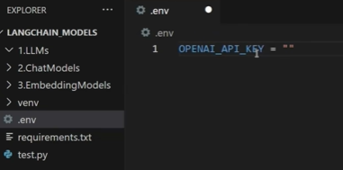
- Loaded using python-dotenv
Why this is critical
Hardcoding secrets is a security risk.
Industry best practice
- Secrets are stored in:
  - Environment variables
  - Secret managers (AWS, Azure, GCP)
- Keys are never committed to Git
This section introduces security awareness early, which is excellent.

21. First LLM Code Demo with LangChain + OpenAI
A simple LLM object is created:
- Model: gpt-3.5-turbo-instruct
- Method used: invoke()
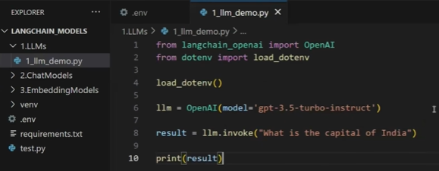
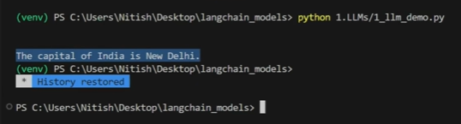
Core learning
- invoke() is the universal execution method in LangChain
- In Invoke() method we will pass the question to the llm
- Llms takes string as an input and also gives string as an output
- Same method appears later in:
  - Prompts
  - Chains
  - Agents
This is a foundational concept.

22. Understanding the LLM Interaction Flow
The flow is made very explicit:
- Import libraries
- Load API keys
- Create model object
- Call invoke(prompt)
- Receive response
Why this clarity matters
This same flow appears in every GenAI system, regardless of complexity.

23. Why LangChain Pushes You Away from LLMs
The instructor clearly states:
- LLM-style code is old
- Chat models are the future
Industry reasoning
LLMs:
- No roles
- No message structure
- No metadata richness
Chat models:
- Support system/user roles
- Enable agents and tools
- Scale better for real applications

24. Chat Models as the Default Industry Choice
A new file is created under chat_models.
Minimal code change
- OpenAI → ChatOpenAI
Key takeaway
LangChain provides a consistent interface, making migration easy.
Industry advantage
This allows companies to:
- Upgrade models
- Switch providers
- Refactor safely

25. Architectural Difference: LLM vs Chat Model
The instructor briefly shows inheritance:
- LLMs inherit from BaseLLM
- Chat models inherit from BaseChatModel
Why this matters conceptually
It explains:
- Why outputs differ
- Why chat models return rich objects
You don’t need to memorize this — just understand the implication.

26. Structured Output from Chat Models
Chat model output includes:
- Content (actual answer)
- Token usage
- Metadata
Industry usage of metadata
- Cost monitoring
- Performance tracking
- Debugging hallucinations
This is production-grade behavior, not tutorial fluff.
Code:
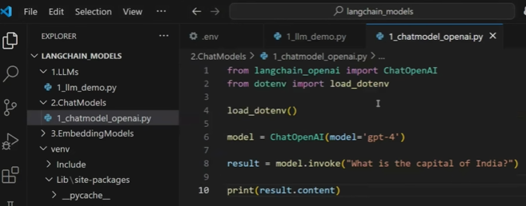

27. Extracting Only the Required Content
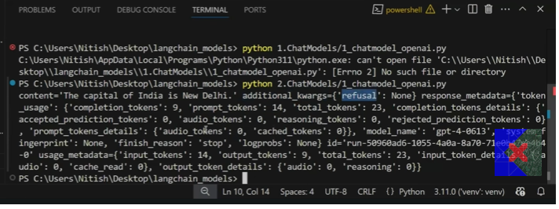
Instead of printing the full object:
- Access result.content
Why this matters
- Clean outputs for users
- Retain metadata internally
Industry pattern
- UI shows content
- Backend logs metadata

28. Model Selection Based on Context Window and Tokens
OpenAI model comparison is briefly discussed:
- Context window
- Max output tokens
Industry decision-making
Model choice depends on:
- Document size
- Expected response length
- Cost constraints
There is no “best model”, only best fit.

29. Temperature as a Product-Level Control
Temperature is explained as a creativity control. (Ranges from 0 to 2 nearly)
Temperature is a parameter that controls the randomness of a large language model output
Lower values (0 – 0.3) – responses are more deterministic and predictable and every time we run the model, we get the same output
Higher values (0.7 to 1.5) – more random, creative and diverse every time we run the model, we get the different and creative answers
Practical mapping
Use case | Temperature
Factual answers - Coding, math (should always return the same value) | 0 – 0.3
Balanced response - Q&A, explanations | 0.5 – 0.7
Creative - Writing, stories | 0.9 – 1.5
Maximum randomness – wild ideas, Brainstorming | >1.5
Industry reality
Temperature is often decided by:
- Product requirements
- Safety policies
- User experience goals

30. Max Tokens as a Cost and Control Mechanism
In the output we get only ten tokens – It is just to reduce the cost of using the API
Max tokens limit:
- Response length
- API cost
Industry importance
- API billing is token-based
- Large-scale systems enforce token caps
This is financial awareness, not just technical tuning.

31. Multi-Provider Strategy: Anthropic (Claude)
Anthropic’s Claude model is introduced.
Why this matters
- Claude often competes with or outperforms GPT models
- Some companies prefer Claude for:
  - Safety
  - Reasoning
  - Policy alignment
Key insight
Your future company may not use OpenAI.
Code:
Anthropic APIs are also paid so we need to create one API key
Whatever variable name we assign for the API key must be used consistently. Otherwise, the load method will not be able to locate the API key.
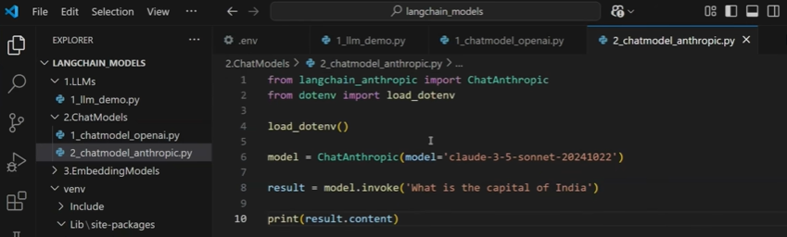

32. Power of LangChain’s Provider-Agnostic Design
Switching from OpenAI → Anthropic requires:
- Minimal code change
- Same invoke() pattern
Industry benefit
- Vendor lock-in is reduced
- Model benchmarking becomes easy
This is one of LangChain’s biggest strengths.

33. Adding Google Gemini into the Same Architecture
Gemini models are introduced using the same pattern.
Key observation
Despite different providers:
- Code structure remains consistent
- Only imports and model names change
Industry takeaway
This enables:
- A/B testing
- Cost optimization
- Regional compliance
We need to create Google Gemini API key(Paid)
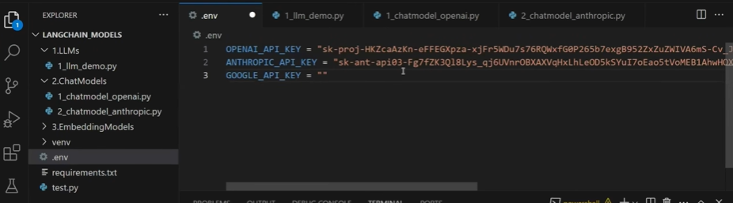
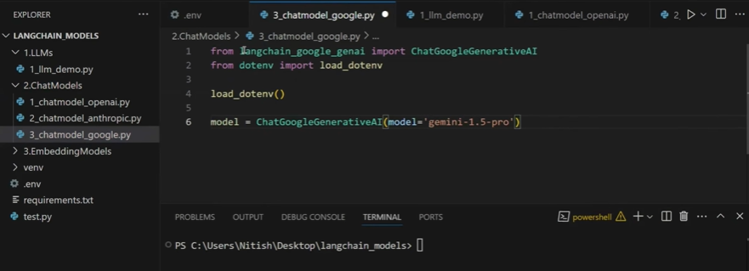

34. Why Closed-Source Models Are Taught First
The instructor acknowledges:
- These models are paid
- This is a limitation
Reason for teaching them first
- They are widely used in companies
- You must understand them to be job-ready

35. Transition to Open-Source Models (Natural Next Step)
The section ends by addressing the biggest concern:
- Cost
- Dependency on paid APIs
This naturally leads into:
- Open-source models
- Local inference
- Embedding-based systems

36. Project Thinking
Suggested project
Multi-Provider Chat Playground
- Same UI
- Switch between:
  - OpenAI
  - Claude
  - Gemini
- Control:
  - Temperature
  - Max tokens
Why this project matters
- Mirrors real industry architecture
- Shows abstraction thinking
- Extremely strong for interviews

37. Section Summary
By the end of this continuous transcript, you now understand:
- Professional GenAI setup
- Secure API handling
- LLM vs Chat models
- Parameter tuning with business impact
- Multi-provider GenAI architecture

38. What Open-Source Models Really Mean (Concept Clarity)
Open-source models are AI models you can download, modify, fine-tune, and deploy yourself, without depending on a company’s API.
Why this section is important
Until now, all models used were:
- Closed-source
- Hosted on company servers
- Accessed via paid APIs
This section changes the control model completely.

39. Core Problem with Closed-Source Models (Industry Reality)
Two major limitations are highlighted:
- Cost
  - You pay per API call / token
- Lack of control
  - Model lives on someone else’s server
  - You can’t modify or deeply customize it
Industry implication
This becomes a blocker when:
- Usage scale increases
- Data is confidential
- Compliance rules exist (finance, healthcare, internal company data)

40. How Open-Source Models Solve These Problems
With open-source models:
- No API cost (if run locally)
- Full control over:
  - Fine-tuning
  - Deployment
  - Architecture
Industry usage
Companies adopt open-source when they need:
- On-prem deployment
- Data privacy guarantees
- Long-term cost control

41. Side-by-Side Comparison (Why It Matters)
Aspect | Open-Source | Closed-Source
Cost | Free (infra only) | Pay per use
Control | Full | None
Data privacy | High | Data leaves system
Customization | Deep | Limited
Deployment | Anywhere | Provider only
This comparison is interview-critical.

42. Data Privacy as a Deal-Breaker Use Case
Key point:
- Confidential documents cannot be sent to OpenAI / Gemini APIs
Why open-source wins here
- Entire processing happens on your machine or private servers
- No data leakage risk
Real-world use cases
- Internal company documents
- Legal contracts
- Medical records
- Proprietary research

43. Popular Open-Source LLMs You Must Know
Only the necessary names are introduced:
- LLaMA - Facebook
- Mistral
- Falcon
- BLOOM
- Domain-specific variants
Industry expectation
You are not expected to know all, but:
- You should recognize these names
- Understand where to find them

44. Hugging Face as the Central Hub
Hugging Face is introduced as:
- The largest repository of open-source AI models
Why this platform matters
- Thousands of models
- One standard interface
- Community + enterprise usage
This is the GitHub of AI models.

45. Types of Models Available on Hugging Face
Models are categorized into:
- Text generation
- Multimodal
- Computer vision
- NLP tasks
Important focus (for this course)
👉 Text generation models, because they power:
- Chatbots
- RAG systems
- Assistants

46. Two Ways to Use Open-Source Models
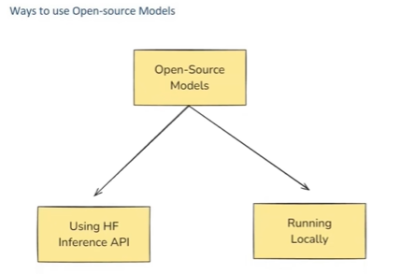
Method 1: Hugging Face Inference API
- Similar to OpenAI API
- Free tier + paid after limit
- Fast to start
Method 2: Local Download & Execution
- Fully offline
- No API cost
- Heavy hardware requirement
Industry practice
- Prototyping → API
- Production / privacy-critical → Local or private cloud

47. Disadvantages of Open-Source Models (Reality Check)
Three major downsides are clearly explained:
- Hardware requirement
  - Large models need expensive GPUs
- Setup complexity
  - Model loading, tokenizers, memory management
- Lower refinement
  - Less RLHF compared to OpenAI
  - Answers whatever we get are not much refines but we can fine tune these models
This honesty is important — no silver bullets.

48. Why Responses Feel Less Polished Than GPT
Reason:
- Open-source models usually have less human feedback fine-tuning (RLHF)
Key takeaway
Quality gap exists — but:
- You can fine-tune
- You gain control
This is a trade-off decision, not a flaw.

49. Limited Multimodal Support (Current State)
At this point:
- Most open-source models are text-only
- Image/audio support is limited
Industry note
Multimodal open-source is improving but still behind closed models.

50. First Hands-On: Hugging Face Inference API via LangChain
A chat model is created using:
- ChatHuggingFace
- HuggingFaceEndpoint
Important abstraction insight
LangChain keeps:
- invoke() same
- Code structure consistent
Only the provider changes.

51. Using Hugging Face Access Tokens Securely
Steps:
- Create token on Hugging Face
- Store it in .env
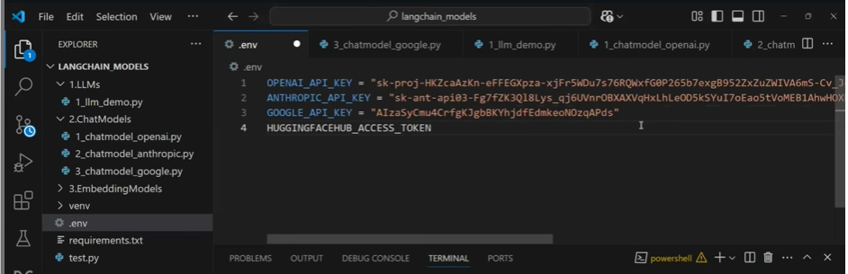
- Load via dotenv
Industry standard
This mirrors:
- AWS secrets
- Azure key vault
- Kubernetes secrets

52. Choosing a Lightweight Model (TinyLLaMA)
Model selected:
- TinyLLaMA (1.1B parameters) – fine tuned on llma model
Why this choice matters
- Smaller models = faster demo
- Lower memory usage
- Practical for learning
Industry analogy
Always start small, scale later.

53. Running Open-Source Models via API (First Approach)
Key point:
- Model is still on Hugging Face servers
- You interact via API
This is open-source without hardware pain.
In this approach, we use the HuggingFaceEndpoint, where we pass the repo_id of the model we are using from Hugging Face along with the task we want to perform using that model.
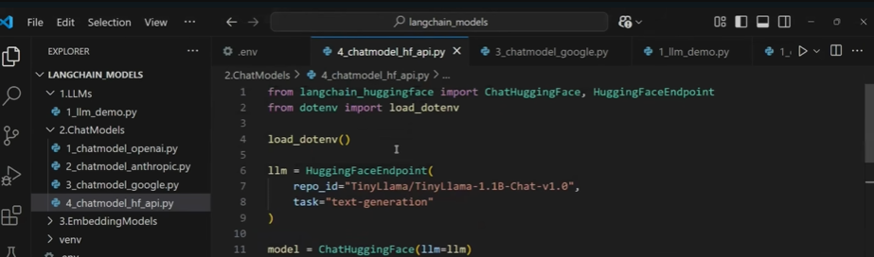
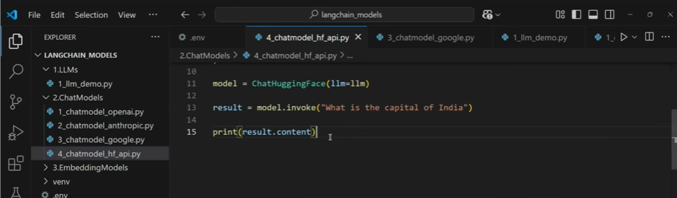

54. Switching to Fully Local Execution (Second Approach)
Now the model is:
- Downloaded
- Cached
- Run on your own machine
Critical learning
- First run is slow (download + load)
- Later runs use cache
This mirrors production inference behavior.
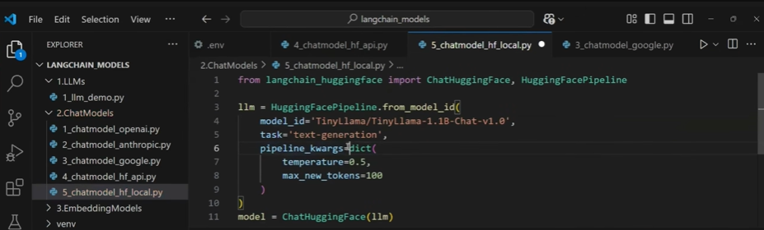

When we run this file, the TinyLlama model along with its configuration files will be downloaded to our machine (nearly 5000 MB in size), and everything will be loaded into RAM.
If a GPU is available, the processing will be much faster compared to CPU execution.
By default, all the model files are downloaded to the C drive.
If we want to store them in a different drive, we can change the download directory by configuring the appropriate path.

Output:
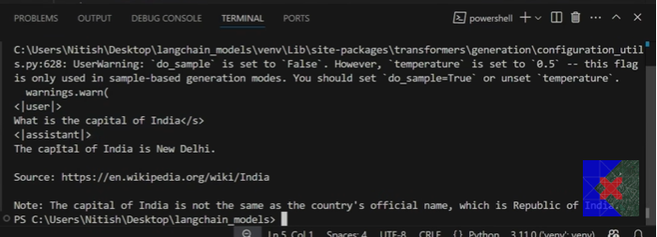

55. Hardware Bottlenecks (Very Real)
Instructor shows:
- 8GB RAM struggles
- CPU inference is slow
- System can freeze
Industry truth
Local LLMs need proper infra, not laptops.

56. Environment Variable for Model Cache Location
Using:
- HF_HOME to change download directory
Why this matters
In real systems:
- Disk management matters
- Cache locations are controlled
This is production-level thinking.

57. Summary of Model Coverage So Far
You have now worked with:
- LLMs
- Chat models
- Closed-source models
- Open-source models
- API-based inference
- Local inference
This is a complete foundation layer.

58. Transition to Embedding Models (Architectural Shift)
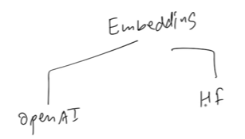
Key reminder:
- Embeddings convert text → vectors
- Vectors capture semantic meaning
This is the backbone of:
- Search
- RAG
- Recommendations

59. OpenAI Embeddings: Single Query
Using:
- OpenAIEmbeddings
- embed_query()
Important control
- Vector dimension size
- Cost vs context trade-off
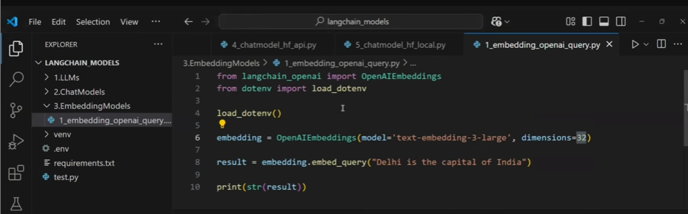
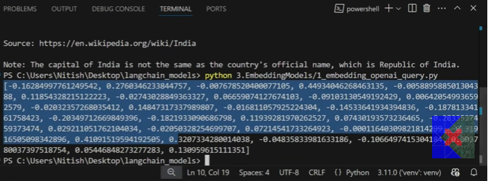
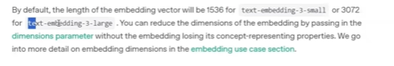
We can change the size of the embedding vector if needed!!

60. Vector Size vs Cost Trade-off (Industry Decision)
Vector size | Context | Cost
Small | Low | Cheap
Large | High | Expensive
Industry rule
Choose minimum dimension that works.

61. Multiple Document Embeddings
Using:
- embed_documents()
Result:
- 2D list
- One vector per document
Why this matters
This is exactly how:
- Knowledge bases
- RAG pipelines
- Semantic search systems work

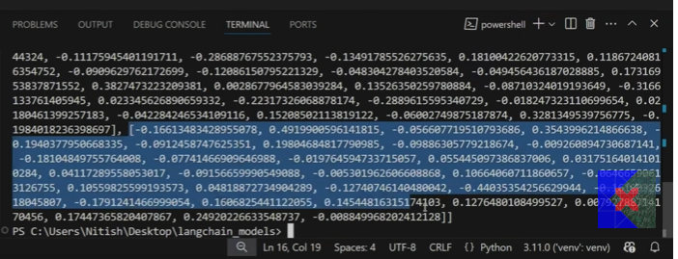
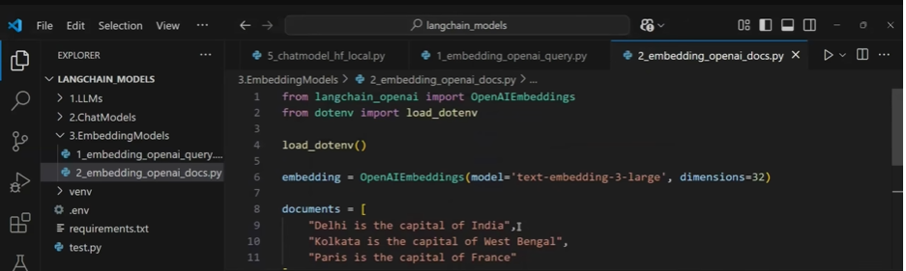
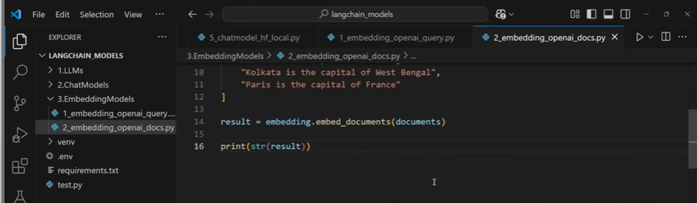

62. Open-Source Embeddings with Sentence Transformers
Model used:
- all-MiniLM-L6-v2
- 384-dimensional vectors
- ~90MB size
Why this model is popular
- Lightweight
- Fast
- Good semantic quality
Used widely in industry.
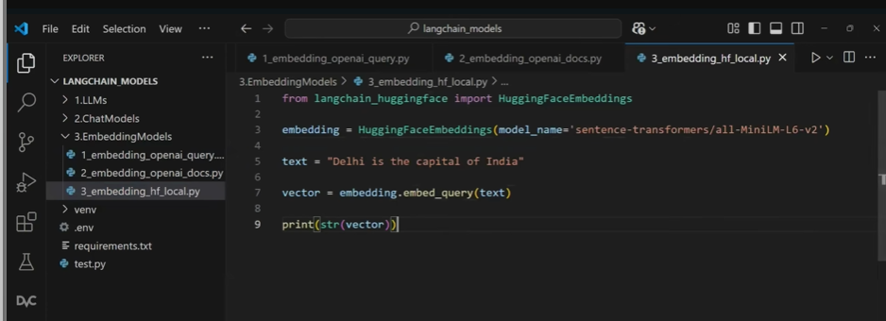
For documents:
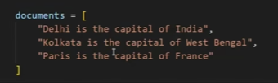
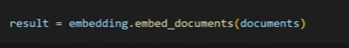

63. Open-Source vs Paid Embeddings (Practical Choice)
Key insight:
- OpenAI embeddings are cheap and high quality
- Open-source embeddings are free but slightly weaker
Industry practice
- Many teams still use OpenAI embeddings
- Because cost is negligible and accuracy is better

64. Foundation for Semantic Search & RAG
This section quietly sets up:
- Document similarity
- Vector databases
- Retrieval-augmented generation
Necessary project hint (only one)
Document Similarity Search
- Embed documents
- Embed query
- Compare vectors
This is a core GenAI project, not optional.

65. Clean Transition Point
At this stage, you now fully understand:
- Models
- APIs vs local
- Embeddings
- Cost vs infra trade-offs
The next logical step:
👉 Semantic Search + RAG Applications

66. Goal of Embedding Models (Problem Statement)
The objective here is to build a simple document similarity (semantic search) application.
- You have a fixed set of documents (example: 5 documents)
- A user asks a question
- The system must identify which document is most related to the question
This is not keyword search, it is meaning-based matching.
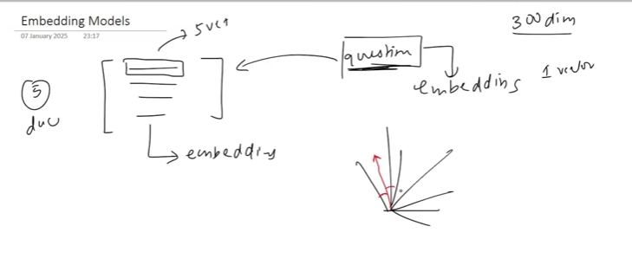

67. High-Level Working of Semantic Search Using Embeddings
The process works in three clear steps:
- Generate embeddings for all documents
- Generate an embedding for the user query
- Compare the query embedding with document embeddings to find the closest match
Key idea:
- All embeddings are vectors of the same dimension
- Comparison happens in a high-dimensional vector space

68. Why Vectors Matter (Intuition, Not Math)
- Each document → one vector
- Query → one vector
- All vectors live in the same embedding space (e.g., 300 dimensions)
The closer two vectors are, the more similar their meanings.
This convert:
“Which text is related?”
into
“Which vector is closest?”

69. Similarity Measurement Using Cosine Similarity
Cosine similarity is used to measure how close two vectors are.
- It measures the angle between vectors, not magnitude
- Output is a similarity score
- Higher score = more semantically similar
Why cosine similarity?
- Works well in high-dimensional spaces
- Industry standard for text embeddings

70. Why This Is the Core of RAG Systems (Industry Insight – Necessary)
This exact logic is reused in:
- RAG (Retrieval-Augmented Generation)
- Knowledge-base chatbots
- Internal document assistants
Difference:
- Here → documents are in a list
- In real systems → documents are in vector databases
But the fundamental logic is identical.

71. Minimal Code Setup (Conceptual Focus)
Key components used:
- OpenAI embedding model
- Environment variable loading
- Cosine similarity from scikit-learn
- NumPy for array handling
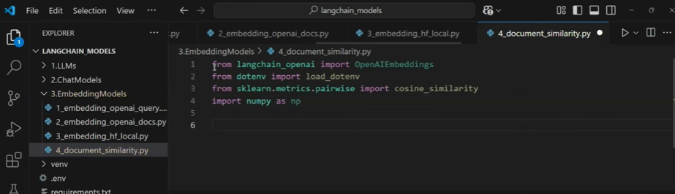
Important note:
- Embeddings are generated once
- Query embedding is generated every time
This distinction becomes critical for cost and performance.

72. Choosing the Embedding Model
Model used:
- text-embedding-3-large
- Custom dimension size (e.g., 300)
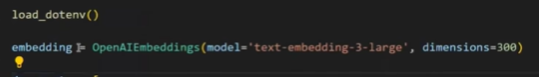
Why dimension matters
- Higher dimension → better semantic representation
- Higher dimension → higher cost & memory
Industry rule:
Use the smallest dimension that gives acceptable accuracy

73. Creating the Document Corpus
Documents are stored as:
- A simple list of strings
- Each string = one logical document
This mirrors real systems where:
- Each PDF page / paragraph = one document chunk
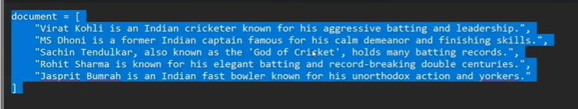
Each line/string is about description about one cricketer

74. User Query as an Embedding
The user’s question is:
- Converted into a single embedding vector
- This vector represents the intent of the question
This is why semantic search works even when:
- Words don’t exactly match
- Meaning still aligns

75. Computing Similarity Scores
Process:
- Compare query vector with each document vector
- Generate a similarity score for each document
Result:
- A list of scores
- Each score corresponds to one document
This is the retrieval phase.
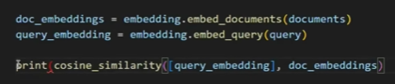
➤ First, we need to generate the embedding vector for the document and the embedding vector for the user query.
➤ Then, we calculate the cosine similarity by passing the query embedding and document embeddings. The query embedding should be provided as a 2D vector.
➤ As output, we get the cosine similarity scores for all the document embeddings, which show how similar each document is to the query.

76. Why Similarity Output Is 2D (Important Detail)
Cosine similarity expects:
- Both inputs as 2D lists
So even a single query vector must be wrapped as:
- [query_vector]
This is a technical detail, but commonly tested in interviews.

77. Interpreting Similarity Scores
Higher score → stronger semantic match.
Example observation:
- Query about “Virat Kohli”
- Highest similarity score corresponds to the Virat Kohli document
This validates:
- Embeddings capture meaning, not just keywords

78. Preserving Document Index While Sorting
Problem:
- Sorting scores can lose document position
Solution:
- Use enumeration to attach indices to scores
- Sort based on similarity score
- Retrieve original document using index
This is a classic retrieval pattern.
We assign index to each cosine similarity score
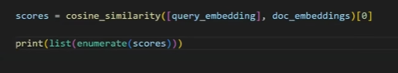
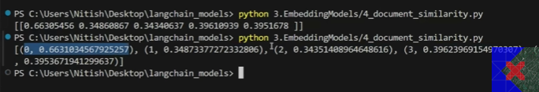
Sort based on the second item
We get the scores in the ascending order

If we want the scores in the in descending order, we use -1


79. Fetching the Most Relevant Document
Final steps:
- Identify highest similarity score
- Extract corresponding document
- Return it as the answer
At this point, the system behaves like:
“Search engine for meaning”
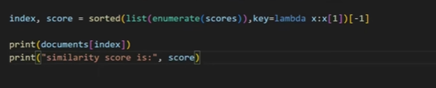
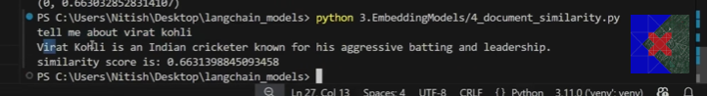

80. Dynamic Query Testing (Why This Matters)
Changing the query (e.g., Kohli → Bumrah):
- Automatically returns a different document
- No hardcoding
- No keyword rules
This shows generalization, which is the power of embeddings.

81. What This System Is Actually Doing
You are performing:
- Semantic search
- Over an unstructured document set
- Without training any model
This is one of the highest ROI GenAI techniques in industry.

82. Major Limitation of the Current Approach
Problem:
- Document embeddings are regenerated every time
- This is:
  - Slow
  - Expensive
  - Not scalable
This becomes a real production bottleneck.

83. Why Vector Databases Are Required (Industry-Critical)
Solution:
- Generate document embeddings once
- Store them in a vector database
- Reuse them for all future queries
This reduces:
- Cost
- Latency
- API usage

84. Retrieval vs Generation (Key Concept)
What you built here = Retrieval
In RAG:
- Retrieve relevant documents (this step)
- Pass them to an LLM
- Generate a final answer
This separation is architecturally important.

85. Why Embedding Models Are So Valuable
Embedding models enable:
- Semantic search
- Document similarity
- Recommendation systems
- RAG pipelines
Without embeddings:
- GenAI applications do not scale beyond chat

86. Only Necessary Project Perspective (One Core Project)
Project: Document Similarity & Semantic Search Engine
Scope:
- Embed documents once
- Store embeddings
- Accept user queries
- Return most relevant documents
Why this project matters:
- Forms the backbone of RAG systems
- Used directly in industry
- Interview-ready
You should not skip this project if learning GenAI seriously.

87. Strategic Transition to Next Topic
This video intentionally stops at:
- Retrieval logic
- Embedding importance
Next logical step (as stated):
👉 Prompt Engineering, then
👉 Combining retrieval + generation
This is the natural GenAI learning curve.

88. Consolidated Mental Model (Final Takeaway)
You now understand:
- What embedding models do
- Why semantic search works
- How RAG begins
- Why vector databases are necessary
This completes the Models component of LangChain properly.

